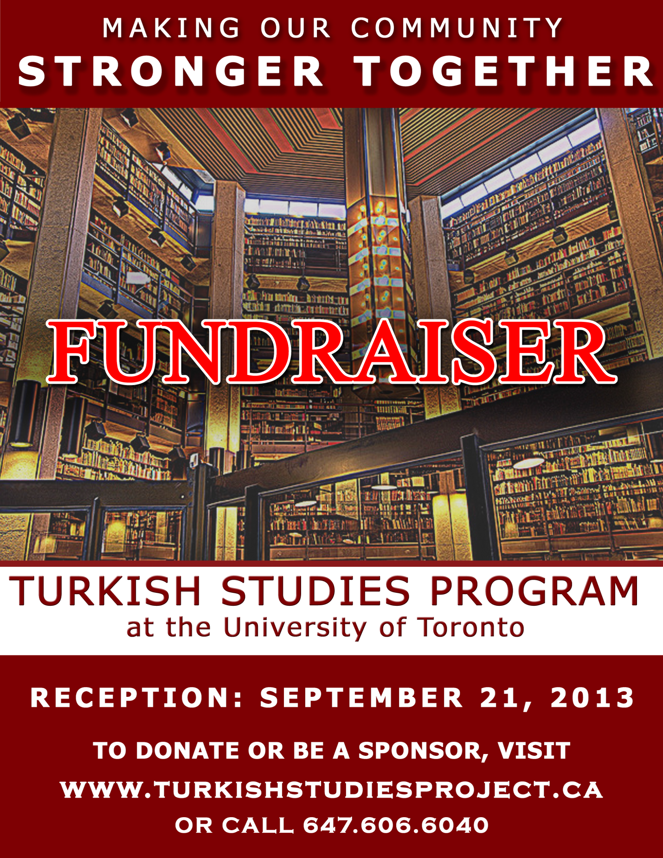

Yes, I want to support PhD students in Turkish Studies and have my gift matched!
0560013535
The Presidents’ Circle: Individuals giving annual combined donations totalling $1,827 or more become members of this U of T recognition program with many exciting benefits.
The Dean’s Society: The Dean's Society honours individuals who donate $2,500 or more annually to support initiatives within the Faculty of Arts & Science. Members of The Dean’s Society will be recognized for their generosity and commitment to excellence, and will receive unique benefits throughout the year. Dean’s Society members will receive all Presidents’ Circle benefits as well.

1.) YOUR INFORMATION:

Name: _________________________________________
Email: ______________________________________
Address: _________________________________________________________
Phone: ___________________
May we recognize you in published donor listings?

Yes, please recognize me as ___________________________________ No

2.) YOUR GIFT: (Please select one option)
Here is my donation of: $______ $250 $500 $1,000

Visa MasterCard Amex

Card Number: ______________________________________________Exp:______/_______

Name on card: ________________________________ Signature: _______________________________________
Cheque, which is enclosed (payable to the University of Toronto)

3.) HOW TO DONATE:

Donate online at https://donate.utoronto.ca/nmc to make a secure online gift. Please designate to the Turkish Studies Scholarship Fund option. Or return this completed form to: Monica Hahm
Office of Advancement, Arts & Science, University of Toronto
100 St. George Street, Suite 2032
Toronto, ON M5S 3G3
Email: monica.hahm@utoronto.ca Phone: 416-946-5616
Your Privacy : The information on this form is collected and used solely for the administration of the University’s advancement activities, undertaken pursuant to the University of Toronto Act, 1971. If you have any questions, please refer to www.utoronto.ca/privacy or contact the University’s Freedom of Information and Protection of Privacy Coordinator at 416.946.7303, McMurrich Building, Room 201, 12 Queen’s Park Crescent West, Toronto, ON M5S 1A8.
Charitable Registration #: BN 1081 62330-RR0001 Solicitation Code: 0570048091
Thank you for your generous support!

The University of Toronto is seeking to expand on the Department of Near and Middle Eastern Civilizations (NMC)’s historic strengths in Turkish culture – language, literature and archaeology – and history to create a program in Turkish civilization of international distinction.

On Saturday, September 21, 2013, the Ambassador and Consul General of the Republic of Turkey will be hosting an event at the Faculty Club located on the University of Toronto campus. The purpose of this event is to bring members of the vibrant Turkish community together to learn about how collectively we can raise the profile of Turkish culture within Canadian society, in partnership with the University of Toronto.

Thank you for your support! The benefits associated with each sponsorship level are as follows:

PREMIERE SPONSORSHIP: $5,000  - Eight (8) guest invitations  - Corporate recognition from stage (verbal by MC)  - Banner display spaces  - Premiere display of logo in event program  - Logo included in PowerPoint display  - Post-event media play if available | GOLD SPONSORSHIP: $1,500  - Four (4) guest invitations  - Logo in event program  - Logo included in PowerPoint display
PLATINUM SPONSORSHIP: $2,500  - Six (6) guest invitations  - Corporate recognition from stage (verbal by MC)  - Prominent display of logo in event program  - Logo included in PowerPoint display | SILVER SPONSORSHIP: $750  - Two (2) guest invitations  - Logo in event program  - Logo included in PowerPoint display

Please fill out the form below to confirm your support as an important sponsor of the September 21st Turkish community event:

Name:
Organization:
Title:
Address:
Phone:
Email:

Sponsorship: □ Premiere ($5,000) □ Platinum ($2,500) □ Gold ($1,500) □ Silver ($750)

Please mail your completed form and cheque payable to University of Toronto to:
Monica Hahm
Office of Advancement, Arts & Science, University of Toronto
100 St. George Street, Suite 2032
Toronto, ON M5S 3G3
Tel: 416-946-5616
Email: monica.hahm@utoronto.ca

