***FROM HOSTILITY TO FRIENDSHIP***

***1915-2015***

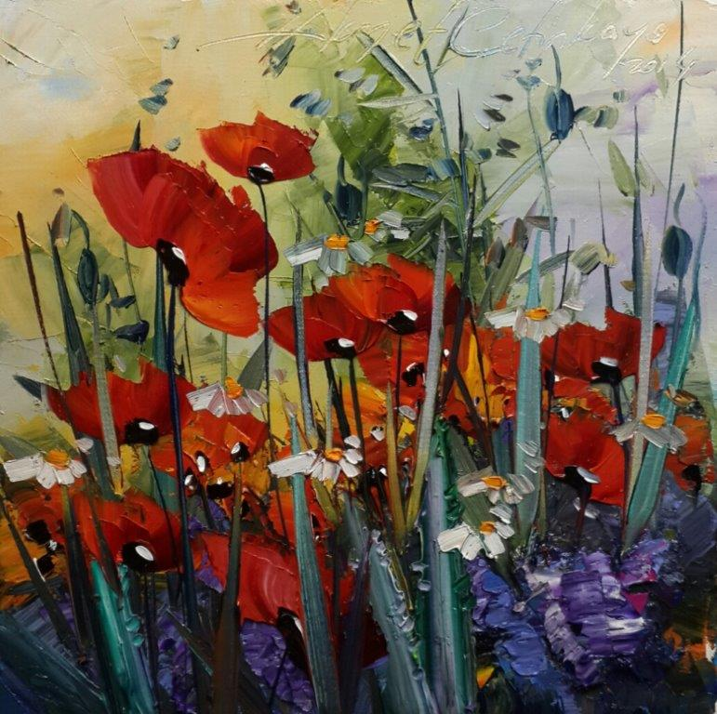

***REMEMBERING THE FALLEN SOLDIERS***

***IN GALLIPOLI WITH POPPIES***

***Exhibition***

***by***

***HİKMET ÇETİNKAYA***

**5-6 March 2015, 8:00am-8:00pm**

***The Rotunda, City Hall***

***100 Queen Street West, Toronto***

*The Battle of Gallipoli of 1915 is the epic and unprecedented story of humanity in the First World War. Although almost 200,000 Turks, Australians, New Zealanders, British, Canadians among others lost their lives, at the end of that catastrophy, human values succeeded to prevail over warfare.  
  
The Battle of Gallipoli is not just a battle, but an extraordinary display of courage, compassion and mutual respect. No battle has created such a strong friendship and everlasting peace among its warring parties in its aftermath.  
  
The famous Turkish Artist Mr. Hikmet Çetinkaya dedicated his prominent work of 40 paintings of Poppies titled "From Hostility to Friendship; 1915 - 2015" to the fallen soldiers lying in peace next to each other in Gallipoli today.*

** **

Turkish Society of Canada in collaboration with Turkish Consulate General in Toronto

***We would like to acknowledge City of Toronto for their support in organizing this event.***