2013 TÜRKİYE SCHOLARSHIPS POSGRADUATE APPLICATIONS STARTED 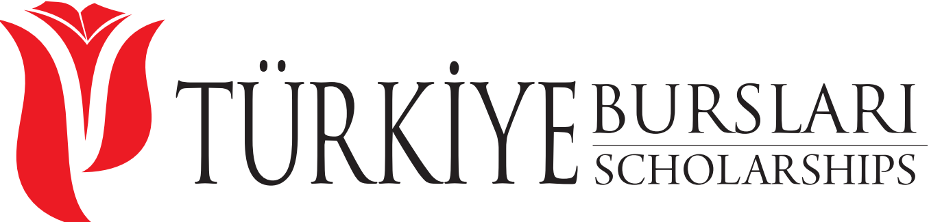

Deadline: March 31, 2013

Postgraduate Scholarship opportunities for International Students willing to study in Türkiye!

Türkiye invites thousands of students from all around the world to study at the best universities with ample scholarship opportunities.

Scholarship program fields are including, but not limited to economics, engineering, communication, political sciences, law, engineering, agriculture, journalism, sociology, literature and architecture.

This program provides scholarships for masters and PhD levels.

For detailed list of departments, universities and application please visit: www.trcholarships.org

Candidates applying for Postgraduate Scholarship Program shall meet the following requirements:
- Being a citizen of a foreign country (Anyone holding or ever held Turkish citizenship cannot apply for this scholarship program),
- Candidates who have already graduated or are likely to graduate from an educational institution equal to that of Türkiye’s in the present academic year,
- For master level applicants who were born no earlier than 01.01.1983,
- For Ph.D. level applicants who were born no earlier than 01.01.1978,
- Candidates who had not or have not been granted a scholarship at the graduate level by a Turkish government institution,
- Candidates who are currently studying at a university in Türkiye cannot apply for the same level,
- Candidates who have completed his/her undergraduate or master’s education in Türkiye must submit ALES (Academic Staff and Graduate Education Test conducted by ÖSYM) or its international equivalent exam deemed acceptable by the universities they are applying to,
- Candidates must have at least 80 % weighted grade point average over their maximum graduation grade.

Required documents
- The application form (Provided at the website)
- A copy of a undergraduate/graduate diploma or document indicating that the candidate is undergraduate/graduate senior student.
- A certified undergraduate/graduate transcript (indicating courses taken and relevant grades of the candidate).
- A copy of a valid ID card (Passport, Birth Certificate, etc.)
- One (1) passport photo.
What Does This Scholarship Cover?
- Free University Education
- Free Turkish Language Classes
- Free Health Care
- Monthly Pocket Money
- Free Dormitory
- Flight Ticket (First Arrival and Departure after Graduation)

How to apply?
Candidates can apply via www.turkiyeburslari.org and www.trscholarships.org web sites. Candidates who apply through internet will primarily create an account by entering an e-mail and password; will log in to the system and fill out the application forms and will finalise the application by uploading the relevant documents on to the system.
Note: 1- The Türkiye Scholarships allow students to study not only in state universities, but also in private universities. Students who have been enrolled in a private university are not granted their scholarships and pay university fee on their own in the case that they do not graduate in academic calendar.
2- Graduate candidates who choose the universities instructing in English must provide the language documents asked by the university that they choose.
